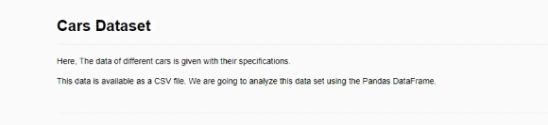

1) Instruction ( For Data Cleaning)

Find all null value in the dataset. If there is any null value in any column. then fill it with the mean of the column



2)Question ( Based on Value Counts )

Check what are the different types of Make are there in our dataset. And, what is the count(occurrence) of each make in the data ?



3) Instruction (Filtering)

Show all the records where Origin is Asia or Europe



4) Instruction (Removing unwanted records)

Remove all the records(rows) where Weight is above 4000



5) Instruction (Applying function on a column)

increase all the values of "MPG_City" column by 3

